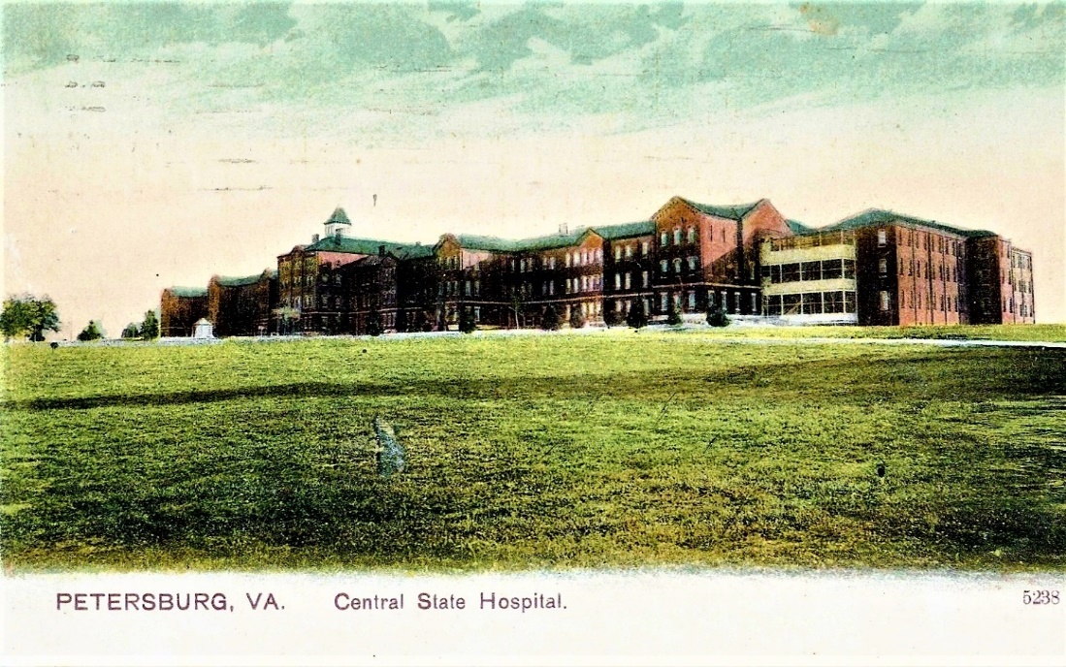
December 16, 2015
Mr. Kevin Massengill,
County Administrator
Dinwiddie County Board of Supervisors
14016 Boydton Plank Road
Dinwiddie, Virginia 23841

Dear Mr. Massengill:

Thank you and the members of the Board of Supervisors for your interest in the Central State Hospital Archives Project. I appreciated the opportunity to share the history of the project with you and the very positive responses from the Supervisors.

As the project moves along, I will provide you with updates and indicate where we may need your support. I have included a list of some of the individuals and organizations that have collaborated with us on the design and implementation of the project to date.

I spend the bulk of my time here in Virginia and at the University of Texas only once per quarter until the project end in 2017. You can reach me easily by email.

Sincerely,

King Davis, PhD
Research Professor
School of Information
The University of Texas at Austin

Mike Hogg Professor Emeritus
Institute for Urban Policy Research
College of Liberal Arts
African and African Diaspora Studies
The University of Texas at Austin
Professor Emeritus
Mental Health Policy
School of Social Work
Virginia Commonwealth University
Richmond, Virginia
king.davis@austin.utexas.edu
Collaborators
- Petersburg Public Library – Wayne Crocker
- State Library of Virginia – John Metz
- Dinwiddie County Historical Society – Artrelle Spicely
- Central State Hospital – Rebecca Vauter, Ronald Forbes and David Chu
- Virginia State University – Lucious Edwards, Sheree Reid
- University of Virginia
- Virginia Commonwealth University – L. Douglas Wilder, Caitlin Foltz
- North Carolina Central University – Halima Davis
- The Cameron Foundation – Handy Lindsay
- National Endowment for the Humanities – Joshua Sternfield
- NASMHPD – SAMHSA – Robert Glover, Meighan Haupt, Brian Hepburn
- The Crawley Company (Fredericksburg, MD)
- Howard University – Thomas Battle
- Boston University – Martin Summers
- University of Kansas Medical School – Kirby Randolph
- Department of Behavioral Health – Dr. Jack Barber, Tammie Peacock,
- Virginia Legislative Services – Brenda Edwards
- Smithsonian Institute – Lonnie Bunch, John Franklin,
- Mellon Foundation – Earl Lewis, Helen Culyer, Donald Waters
- Texas A&M University – Richard Furuta
- Stanford University – Gary Geisler
- The University of Texas at Austin – William Powers, President
- The Department of History – Virginia Tech
- Virginia Commonwealth University – History Department

